Patrick Trinkle
CMSC461
Project 1 Phase B

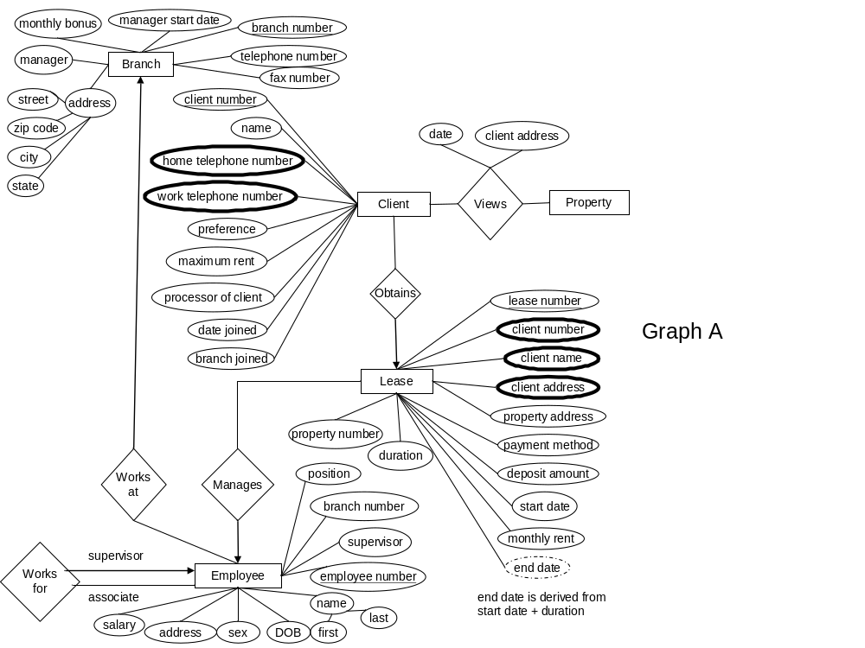Graph A

Graph’s A & B depict the relationships between Employees, Clients, Property Owners, Branches, Newspaper Advertisements, Property, and Leases. The following are constraints on the relationships: each employee can manage at most 30 properties; each lease has a minimum duration of 3 months with a maximum of 24. A client entity can only have one view relationship of a property in the same day. There are no other restraints on the system beyond those depicted in the graphs. Note on the graphs, PDFCreater makes the double lines just look bold.
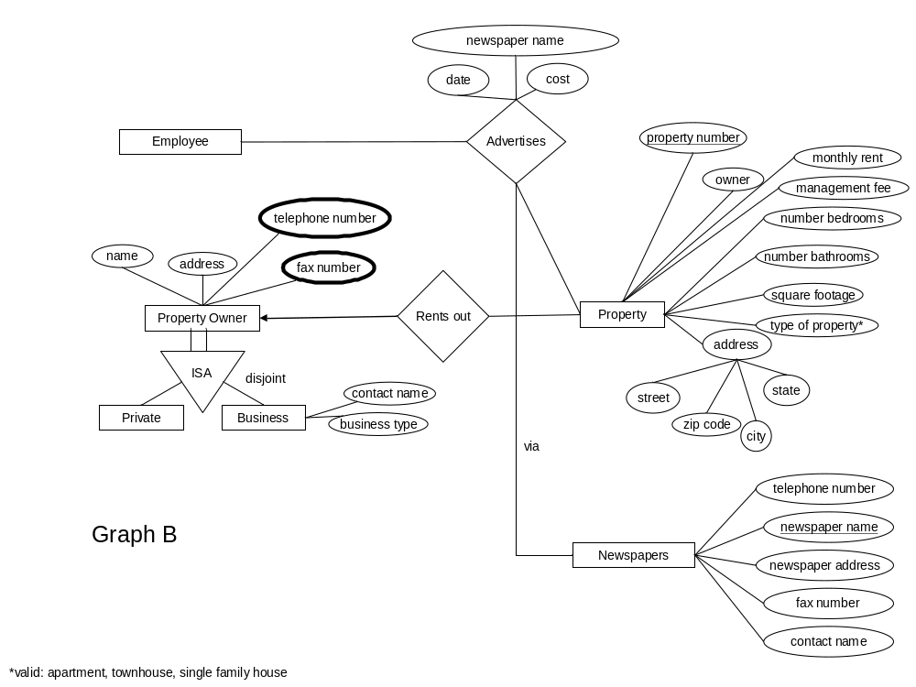Graph B

